Digital Content
Development Guide
(COVID-19)

This is intended to be an open-source document with no authorship.

The initial draft has been prepared by a team member of the Pak Alliance for Maths and Science, and any further additions/deletions can be made by the user(s).

We would appreciate you sharing your input on this with us at info@mathsandscience.pk; PAMS will be sharing updated versions through its website.

Table of Contents
The need and usage of digital content 3
Technical recommendations 4
Duration 4
Size 4
Recording 4
Editing 7
Content (chapter/concept/SLOs) 8
Script 9
Voice over 10
Product Quality 10

The need and usage of digital content
COVID-19, extended schools’ closures, learning losses, distance-based learning, experimenting with blended learning models
Provides opportunity for teachers and educators to organize their thoughts, think of content and learning progression framework independent on textbooks
While digital content development only requires building certain skills, not necessary for someone with a good voice over to also have the same level of editing skills or is a good script writer. Content development has to be a team effort, with multiple educators contributing towards a finished product.
Content re-cap, always assume that a concept has to be taught from start till end, and not only based on the content available in the textbook. Revisit concepts introduced in earlier grades to ensure that students are able to see and connect the learning progression.

Technical recommendations

Duration
For videos to be shared via WhatsApp, an ideal length is 2-3 minutes. Research shows that students’ engagement drops off significantly after the first 6 minutes for online learning (on computer/laptop); unfortunately, similar studies are not available for learning content shared via WhatsApp.

Size
For videos to be shared via WhatsApp, the size of any video file should be less than 20MB to enable users to easily download it on a 3G network.

Recording

Location
Choosing the right place to shoot the video is important to ensure that the other factors come together nicely and the end product is of quality.
Do:
- Choose a well-lit room
- Set up a backdrop, preferably of a neutral color and with minimal pattern. This way the concentration is on the subjects of the video instead of the backdrop. In most cases, a blank white paper does the trick.
- Choose a room/location with no or less ambient noise.
Don’t:
- Shoot in a room where the lighting keeps changing.
- Have a light facing the camera in the backdrop as it shines in the camera lens and creates a distraction.
- Record at a location where there is a shadow or reflection on the content being shared

Camera
To ensure quality production, good camera placement and angle is crucial. The camera needs to be in a place where it is able to capture the activity being demonstrated or content being shown in the best way possible.
Camera stability is an important aspect of video making. Thus, videos developed should be made by putting the camera on a makeshift stand. These stands can be Do-It-Yourself (DIY) (examples shared later), keeping the video making process low-cost. The possible but non-exhaustive list of camera settings follows.
Do-it-yourself-stand
Do:
- Keep the phone in portrait mode for the best viewing experience of the audience.
- Make a do-it-yourself stand to keep your camera. Example stands are shown below:
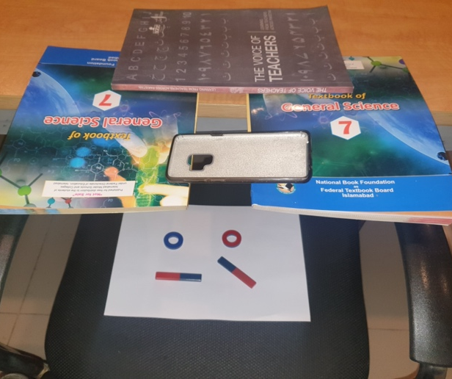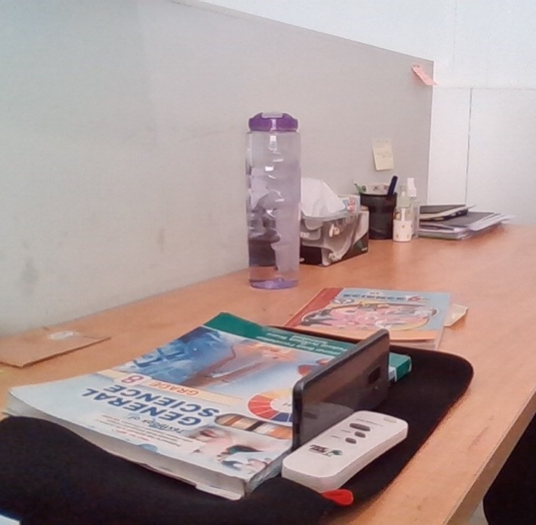
Figure 3: Top View DIY Stand Figure 4: Side View DIY Stand
- The activity should be demonstrated in the middle of the frame with camera’s focus on the activity.
- Choose a camera setting such that the motion is captured clearly.
- Ensure the frame you’ve set is capturing the whole activity being demonstrated. If a part of the activity is out of the frame, video engagement potential greatly decreases.
Don’t:
- Hold the camera in your hand as hand tremors do show up on the final video and compromise the quality of the video.
- Keep the camera on a shaky surface. Instead find a sturdy place to setup the camera.
- Utilize some part of the camera frame. Ensure the whole frame is being used with the activity in the center of the frame.
Top View:
This view can be used for videos where the motion of the video is in the horizontal plane. The Do-it-yourself stand for this can be arranged on a desk or table, the surface below which will be the frame of the video.
A sample top view is shown below:
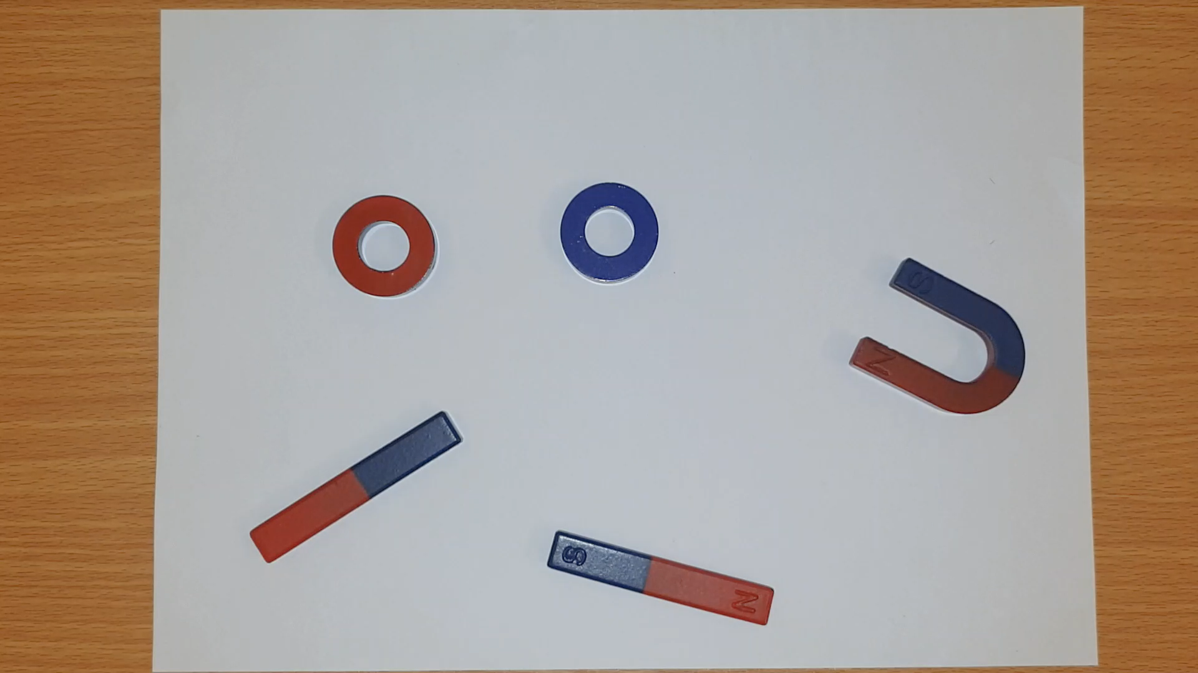
Figure 1: Top View
Side-View:
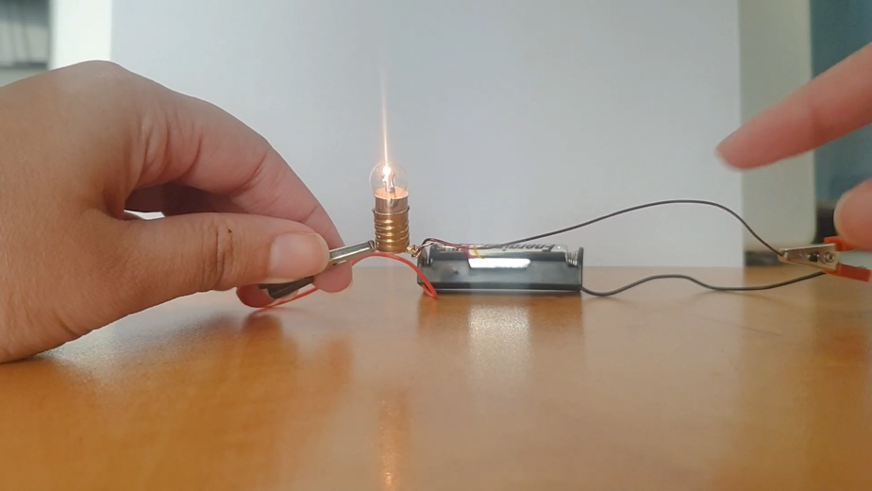
This view can be used for videos where the motion of the video is mainly in the vertical plane. The DIY stand for this can be made on any surface on the level of where the activity will be demonstrated. If the activity is being demonstrated in close proximity to the camera, a background in form of a sheet will help with limiting the depth of the video and eliminating distractions in the background. A sample side view is shown here.

Figure 2: Side View

These are recommendations of tested camera settings, however, the video maker can choose any other setting that captures the motions of the video in the most suitable manner.

Lighting
The right amount and angle of lighting is important for a video to be pleasant watch. Underexposed and overexposed videos lose their appeal while shadows distract the viewers. Room lighting is enough for a video. It can be supplemented with the phone’s flash or a lamp, if required. Light should be as such that the props used in the video are visible clearly. Shadows can be countered by providing light from the direction where the shadows are falling or by keep the activity as close to the backdrop as possible. The later minimizes the effects of the shadows formed instead of eliminating the shadows.
The amount of light appropriate also depends on the camera being used and its aperture. Thus, light setting varies from camera to camera.
Do:
The light source should be behind the camera lens and facing the subjects. Light sources in the video frame may flare up, as shown below, and serve as a source of distraction in the video.
Keep a mobile source of light to provide light in the direction necessary.
Shoot is a well-lit room.
Don’t:
Use direct light in such a way that it reflects any surfaces in the frame, such as glass, and created a sharp reflection.

Figure 5: Flared lights facing the camera

Editing
As editing is a skill that needs to be learned and is time consuming to do that, try to minimize this process. However, basic editing such as trimming videos, embedding audio and text in them is easily implementable. These editing features are readily available on phone and computer applications, two of which as ‘vlogit’ on Android Play Store and ‘Video Editor’ on Windows.
Do:
Mute the audio of the original video while embedding a voice over.
Don’t:
Add flashy effects that break the smooth progression of the video.

Content (chapter/concept/SLOs)
Before the development process starts, the content maker needs to be clear on what concept the content cover will. This is to crucial identify as it manifests as clarity in the content development’s later stages.
It is suggested that the content developer targets to make 2-to-3-minute video(s). The concept should be divided into videos that show the progression in the concept being built. For instance, if ‘Magnetism’ is to be covered. The progression may go as follows:
- Introduction to Magnets
- Magnetic Fields
- Magnetic Field Lines
- Interaction of two Magnetic Fields
- Electromagnets

Do:
Decide and map out the number of videos it will take for a concept to be covered.
Research about the concept and understand it fully before going ahead to ensure that the correct concept is being conveyed in the videos.
Don’t:
Try to cover a whole chapter in one video. This way the product is ineffective as either the video will be too long or too complicated.

Script
Script development is the foundation on which content development stands. The maker needs to write an engaging script that communicates the concept targeted with ease while retaining audience’s attention. Scripts should be well thought and revised multiple times for the most time effective and impactful communication.
Do:
Start with a hook and transition into concepts smoothly.
Keep your tone conversational and semi-formal.
Take the liberty to use any comical references and wit that may capture your audience’s attention.
Write the script in a language understandable to the majority of the intended audience, which in our case is Urdu.
Develop the complete script beforehand.
Keep the length of the script such that it can be covered in a 2-to-3-minute video.
Write script pointers to look at while recording the audio for a cohesive and smooth narration.
Don’t:
Use any foul or slang language.
Assume your audience knows the meaning to technical words so explain their meanings in the video.
Use any political, sectarian or racist language or references.

Voice over
Noise free audio and a good toned narration contribute greatly towards the quality and engagement potential of a video. Audio to the video can be provided in the two of the following ways:
- Narration in the video: The video-maker provides the audio while demonstrating while shooting the visuals. However, unwanted noise may also become part of the audio in this case unless a noise free environment is chosen.
- Voiceover: The video-maker mutes the audio of the video made and records a separate audio which can then be embedded in the video using a readily available video editing software. It is upon the maker’s convenience to record the voiceover first and demonstrate in the video accordingly or vice versa.

Do:
Speak in a clear and crisp manner with proper enunciation.
Don’t read a written script while making the video. You can get help by using script pointers but reading a script comes off as uninteresting and boring.
Change your tone while narrating to emphasize some words and phrases.
Prefer a voiceover whenever there is unwanted noise in the video.
Record the voiceovers in a quiet environment.

Don’t:
Speak in a low volume. Keep your volume loud enough so that it does not need to be amplified while editing as that also amplifies the noise.
Breathe into the microphone. Keep the microphone at an appropriate distance so that it doesn’t pick up breathing sounds.
Add music. If necessary, add soft music with appropriate volume.

Product Quality
Content coverage of the material in a textbook requires customized student engagement techniques. While the one documented in this guide is only one way to engage students, it is important to ensure that each video is of a quality which a student would like to watch and learn from. The intent (hopefully) is not to produce content because a notification tells us to. Happy Teaching!

